* API – Application Programming Interface
* For every problem, we will develop an API
* API contains business logic
* We can create API in different languages, we will develop API in Python
* We will use FAST API framework of Python to develop API
* Framework provides set of tools, structure and instructions
* API includes code, documentation, mock etc.
* We can write code of API and we need to create documentation, mock etc. of API manually
* FAST API framework provides documentation, mock etc. automatically
* For an Artificial Intelligence API, OpenAI specification is required
* Cloud is used to share application with users
* Cloud computing is actually AWS servers on rent
* 1) API – Backend

2) Graphical User Interface (GUI) – Mobile App, Web App, Windows App

3) CUI – Conversation User Interface – Chabot, voice, video

* ChatGPT is sharing information and now, it is taking actions as well because of having IQ (Intelligence Quotient), Emotional Quotient (EQ) and Adversity Quotient (AQ)
* GPT stands for “Generative Pre-Trained Transformers”
* GPT is available
* If customize GPT then it is called Custom GPT
* ChatGPT is LLM
* To communicate with LLM, we provide input which is called “Prompt”
* There are two types of Prompt

1 – System Level Prompt

2 – User Level Prompt

* GitHub organization : <https://github.com/panaversity>

X---------------------------------------------------------------------------------------------------X

* Repository : <https://github.com/panaversity/learn-cloud-native-modern-python>
* GPT created Web App, Mac App and Mobile App but not Windows App.
* Open : <https://chatgpt.com/>
* SignUp account and then Login account
* “Create” is used create custom GPT but enable only for Paid account while “Explore GPTs” used to search custom GPTs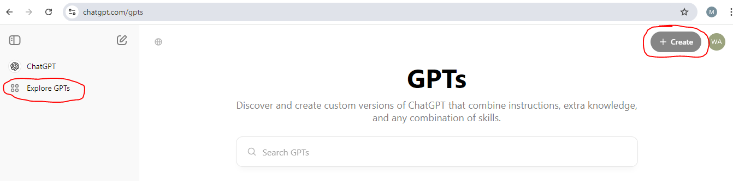
* When you click on “Create” button then prompt line will appear
* First provide prompt to create gpt

Prompt: I want to create quiz gpt for prompt engineering quiz

* Secondly, provide title name of custom gpt

Prompt: Prompt Engineering Quiz PIAIC

* Thirdly, provide actions to perform

Prompt: Ask 3 Questions

* LLMs are Meta 3.1, Gemini, and Llama etc. Best LLM is “ChatGPT4”
* Install below applications in mobile

1. ChatGPT
2. Gemini
3. Copilot

* Install Docker Desktop
* Code executed everywhere where Docker is installed
* World’s 98% servers are on Linux operating system